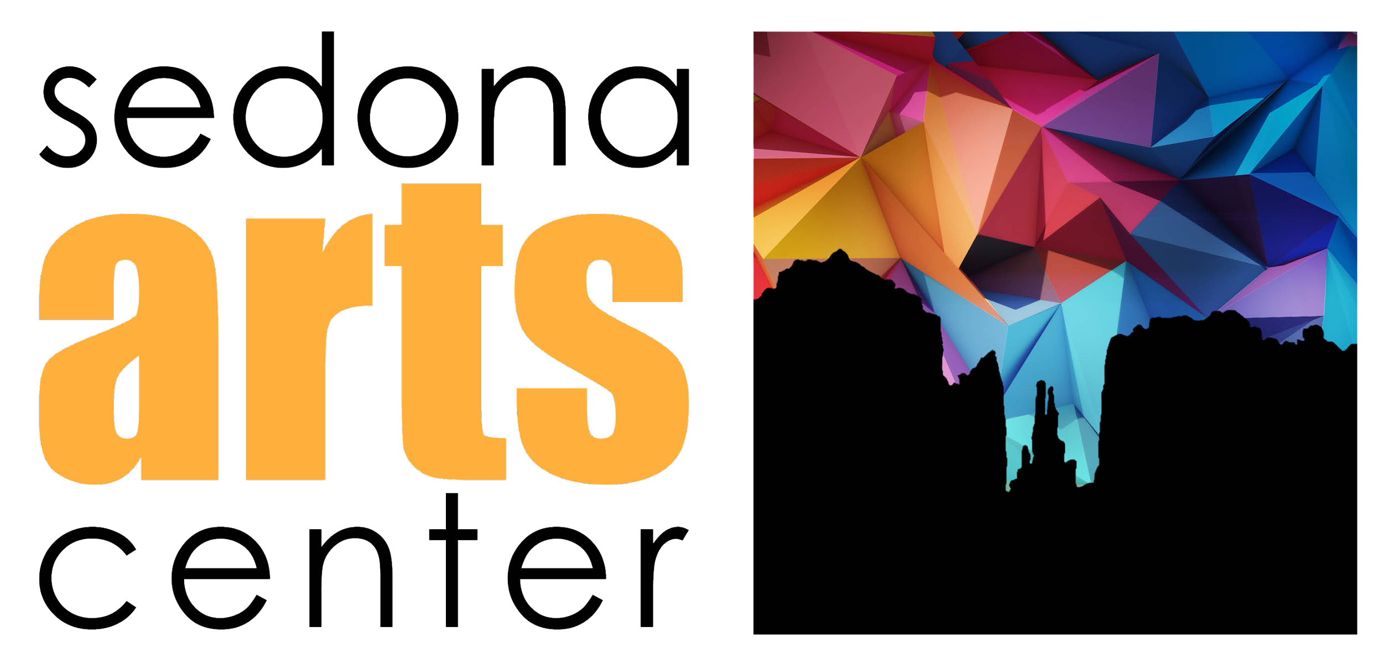

April 2025 Dear Student,
This summer, Sedona Arts Center will oﬀer its fourth year of Gallery 928, a unique art apprenticeship
program for teens ages 15 to 18. Based on Chicago's infamous Gallery 37 summer public art program started in the 1980s, students will be hired to apprentice with a master artist to create a public art mural for the Sedona Arts Center.

This job opportunity is open to up to 12 artistic teens interested in expanding their skills and knowledge in the public art ﬁeld as well as learning other art mediums and techniques. In partnership

with Yavapai College, the students chosen to participate in the program will receive 3 free college

credits. Students will also be paid a stipend of $500 from Sedona Arts Center for their participation. Other program details include:

- Location: Gallery 928 program will be held at Sedona Arts Center, 15 Art Barn Road, Sedona
- Schedule: Monday-Thursday 9am to 3pm starting on June 2-June 27, 2025.
- Transportation is the responsibility of the participant
- Participation: Participants must be able to complete the full program to receive the college credits and stipend
If you are interested in applying, please submit the Gallery 928 application by Friday April 25, 2025 and include letters of reference, and images of your artistic work. Qualiﬁed applicants will be asked to participate in an interview to be considered for one of the 12 spots. If you have any questions, please contact Bernadette at bernadette@sedonaartscenter.org.
Very truly yours,

Bernadette Carroll Chief Operating Oﬃcer

Sedona Arts Center · PO Box 569 · 15 Art Barn Road · Sedona, AZ 86339 · 928-282-3809

